Lab – Researching Subnet Calculators

1. Objectives

Part 1: Review Available Subnet Calculators

Part 2: Perform Network Calculations Using a Subnet Calculator

1. Background / Scenario

While it is important to understand how to convert a decimal IP address to its binary format and apply the bitwise ANDing operation to determine the network address, it is also a tedious and mistake-prone process. To assist with these calculations, many network administrators make use of an IP subnet calculator utility program. A number of these types of programs have been developed that can be downloaded or run directly from the Internet.

In this lab, you will be introduced to a few of the free IP subnet calculators that are available. You will use a web-based IP subnet calculator to perform the network operations in this lab.

1. Required Resources

Device with Internet access

1. Review Available Subnet Calculators

In Part 1, you are introduced to two types of subnet calculators: client-based (programs that are downloaded and installed) and web-based (utilities that are run from a browser).

* 1. Review client-based subnet calculators.

Solarwinds provides a free subnet calculator that can be downloaded and installed on a PC running a Windows operating system. You will be required to provide personal information (Name, Company, Location, Email Address, and Phone number) to be able to download this program. You can download and install the Solarwinds Subnet Calculator at [www.solarwinds.com](http://www.solarwinds.com).

If you have a PC running Linux, it is recommended that you use the **ipcalc** utility (available with most Linux distributions). Use the **apt-get install ipcalc** command to install ipcalc on a PC running Linux.

* 1. Use a web-based subnet calculator.

Web-based subnet calculators do not require installation, but you do need Internet access to use them. The following web-based subnet calculator is accessible from any device that has Internet access, including smartphones and tablets.

* + 1. From your browser, go to [www.ipcalc.org](http://www.ipcalc.org) and click the **IP Subnet Calculator** link.

**Note**: Several other useful utilities are also listed on the menu, such as MAC vendor lookup, whois lookup, and DNS lookup.

**Note**: At the time of this writing, a page formatting issue was encountered when viewing the [www.ipcalc.org](http://www.ipcalc.org) website using Internet Explorer (Version 9). While the site functioned correctly, you may want to consider using another browser (Firefox or Chrome) when accessing this site.

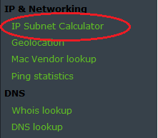

* + 1. On the IP Subnet Calculator screen, enter an IP address and subnet mask or an IP address and CIDR prefix notation. Examples of how to enter each of these are shown in the Introduction area.

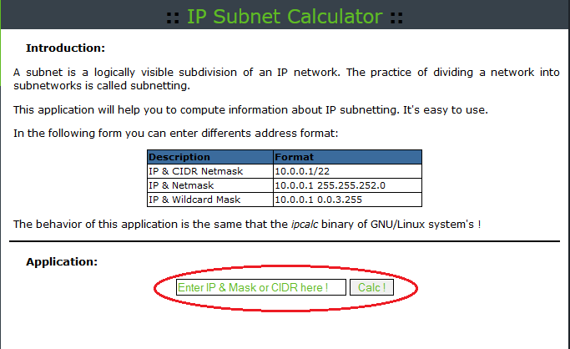

* + 1. In the Application field, enter **192.168.50.50/27** and click **Calc!**. The next screen displays a table with network information in both decimal and binary formats.

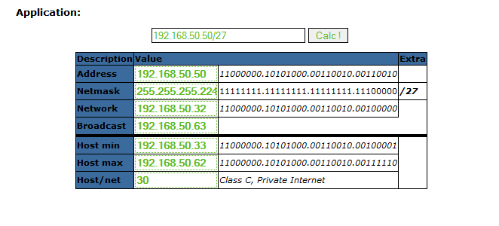

* + 1. Using the information provided in the example above, answer the following questions.

What is the network address? ____________________________

What is the subnet mask? _______________________________

How many hosts will this network support? __________________

What is the lowest host address? _________________________

What is the highest host address? ________________________

What is the broadcast address? __________________________

1. Perform Network Calculations Using a Subnet Calculator

In Part 2, use the [www.ipcalc.org](http://www.ipcalc.org/) web-based subnet calculator to fill in the tables provided.

* 1. Fill in the following table for address 10.223.23.136/10:

|  |  |  |
| --- | --- | --- |
| Description | Decimal | Binary |
| Address | 10.223.23.136 |  |
| Subnet mask |  |  |
| Network address |  |  |
| Broadcast address |  |  |
| First host address |  |  |
| Last host address |  |  |
| Number of hosts available |  | N/A |

What type of address, public, or private? _____________

* 1. Fill in the following table for the 172.18.255.92 address with a subnet mask of 255.255.224.0:

|  |  |  |
| --- | --- | --- |
| Description | Decimal | Binary |
| Address | 172.18.255.92 |  |
| Subnet mask | 255.255.224.0 |  |
| Network address |  |  |
| Broadcast address |  |  |
| First host address |  |  |
| Last host address |  |  |
| Number of hosts available |  | N/A |

What is the CIDR prefix notation for this network? ________

What type of address, public, or private? _____________

* 1. Fill in the following table using the 192.168.184.78 address with a subnet mask of 255.255.255.252:

|  |  |  |
| --- | --- | --- |
| Description | Decimal | Binary |
| Address | 192.168.184.78 |  |
| Subnet mask |  |  |
| Network address |  |  |
| Broadcast address |  |  |
| First host address |  |  |
| Last host address |  |  |
| Number of hosts available |  | N/A |

What is the CIDR prefix notation for this network? ________

What type of address, public, or private? _____________

Where would you most likely find a network like this being used?

_______________________________________________________________________________________

* 1. Fill in the following table for the 209.165.200.225/27 address:

|  |  |  |
| --- | --- | --- |
| Description | Decimal | Binary |
| Address | 209.165.200.225 |  |
| Subnet mask |  |  |
| Network address |  |  |
| Broadcast address |  |  |
| First host address |  |  |
| Last host address |  |  |
| Number of hosts available |  | N/A |

What type of address, public, or private? _____________

* 1. Fill in the following table for address 64.104.110.7/20:

|  |  |  |
| --- | --- | --- |
| Description | Decimal | Binary |
| Address | 64.104.110.7 |  |
| Subnet mask |  |  |
| Network address |  |  |
| Broadcast address |  |  |
| First host address |  |  |
| Last host address |  |  |
| Number of hosts available |  | N/A |

What type of address, public, or private? _____________

1. Reflection
   1. What is an advantage of using a client-based subnet calculator?

_______________________________________________________________________________________

_______________________________________________________________________________________

* 1. What is an advantage of using a web-based subnet calculator?

_______________________________________________________________________________________

_______________________________________________________________________________________